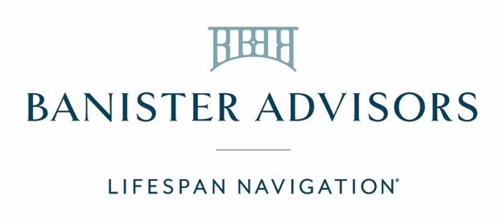

Banister referral language

I wanted to make you aware of a resource that might be useful given your current situation.
Banister Advisors offers a unique service to help families like yours to get through overwhelming circumstances, in the best manner possible. They provide a compassionate approach and are highly effective given their backgrounds in medical social work, strategy consulting, law, conflict resolution, and behavioral health support. People often call them when they aren’t sure where else to turn.
Banister’s expertise is in supporting clients who may benefit from guidance outside the direct expertise of their current professional team. Broadly speaking, they help individuals and families facing physical and mental health issues/crises (all ages, pediatric to geriatric), family decision-making conflicts, complex eldercare, end-of-life planning, bereavement, after loss, and the non-legal tasks for estate settlement. I trust their team to handle sensitive concerns discreetly, efficiently, and appropriately.
You can learn more at banisteradvisors.com. If you’re ready to connect with them now, you can easily book a 15-minute conversation with one of their Navigators using this link: https://schedule.banisteradvisors.com/

